**Bug Title:** Password Visibility Icon Functioning in Reverse

**Bug Description:**The password visibility icon in the login/signup form is working opposite to its expected behavior. When the eye icon is clicked, the password field is hidden instead of being revealed, and vice versa. This issue affects the user experience and may cause confusion when entering passwords.

**Steps to Reproduce:**

1. Open the application and navigate to the login or signup page.
2. Enter a password in the password field.
3. Click on the "eye" icon to toggle password visibility.
4. Observe that the password field is hidden when it should be visible, and visible when it should be hidden.

**Expected Result:** Clicking the eye icon should toggle password visibility correctly:

* Eye open icon → Password should be visible.

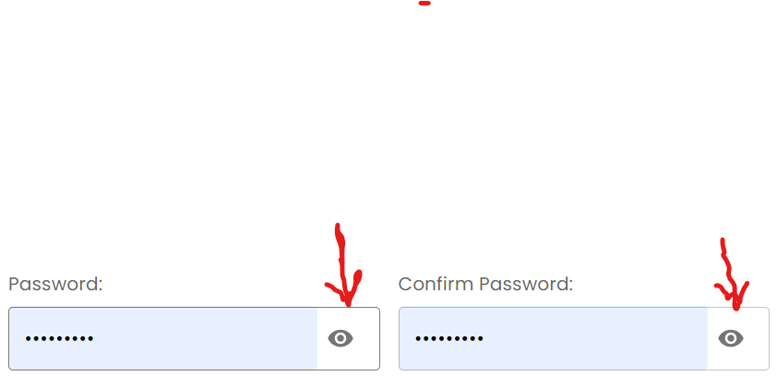

* Eye closed icon → Password should be hidden.

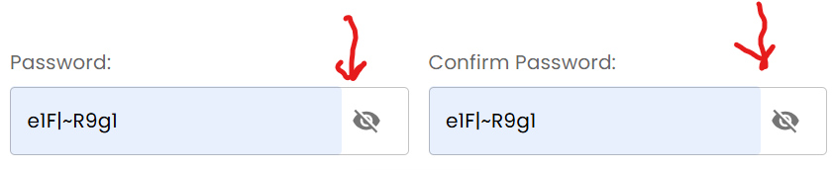

**Actual Result:**

The password visibility icon behaves in reverse.